Translatewiki.net
  - Community-driven localization platform

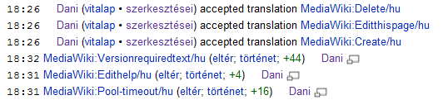
Translatewiki.net is a MediaWiki-based collaborative localization platform for free software projects. It unites the openness and flexibility of the wiki model with the power of modern translation tools.
- MediaWiki provides the sophisticated communication and change tracking features seen in Wikipedia (edit summaries, list of recent changes, watchlists, community pages, talk pages, user pages).
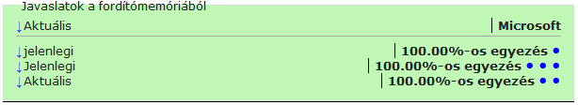
- The translation memory and machine-translated suggestions (Google Translate, Microsoft Translator, Apertium) speed up the work, and make it easier to keep translations of similar texts consistent: you can navigate with a single click between all messages which have (in the source language) the same content.
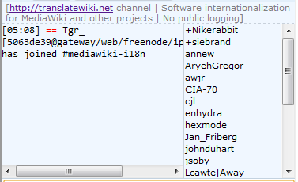
- The workflow can be adjusted to the requirements of the project: the system supports marking translations as verified, gettext import/export, and direct integration with SVN, Git or other version control systems. The translations are wiki pages themselves, so the MediaWiki API provides full access to their contents and history.

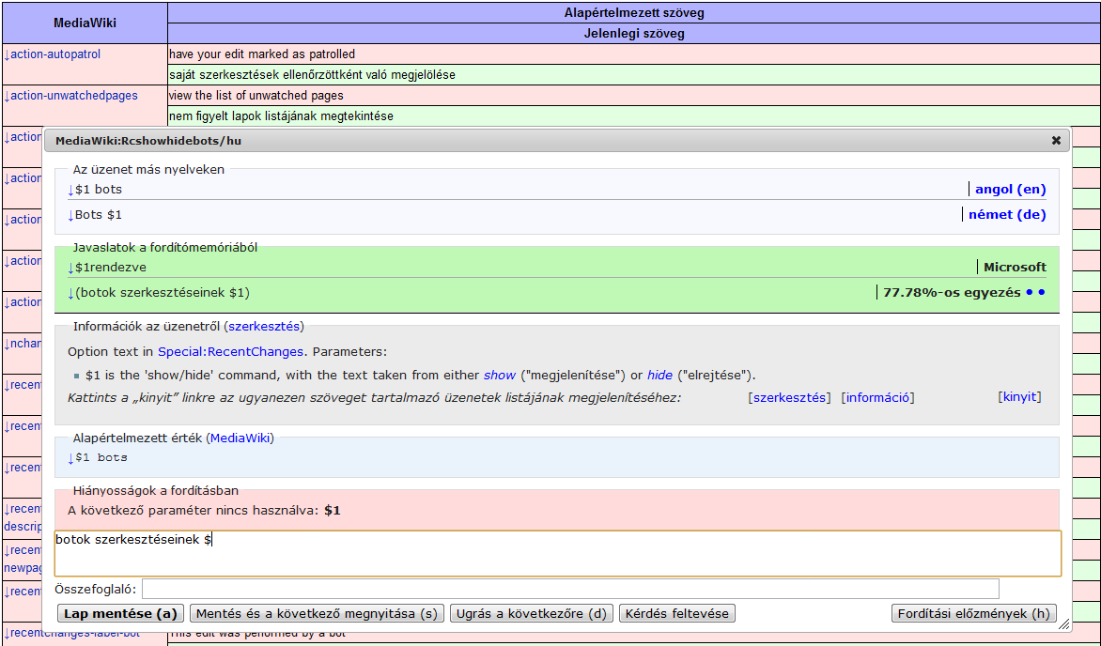
- Translatewiki is used successfully by several large free software projects (for example MediaWiki, OpenStreetMap, FreeCol, StatusNet, MantisBT), and it has a large community (more than 500 active translators in hundreds of languages in 2011) with its own forums and an active IRC channel.
Machine-translated suggestion
Comment about the change

Translation of the message

http://translatewiki.net
translatewiki@xs4all.nl
#mediawiki-i18n@freenode.net
Joining / more information
The structure of Translatewiki's edit interface
Error report from the real-time syntax checker
Instructions for translating the specific message, editable by the translators
Similar messages from translation memory (can be opened for editing by clicking on the dots)
List of existing translations in the languages known by the translator

